LOGIN USING SUPER ADMIN->click on my orgs
user will navigate to the page->landing page for superadmin
flow for admin
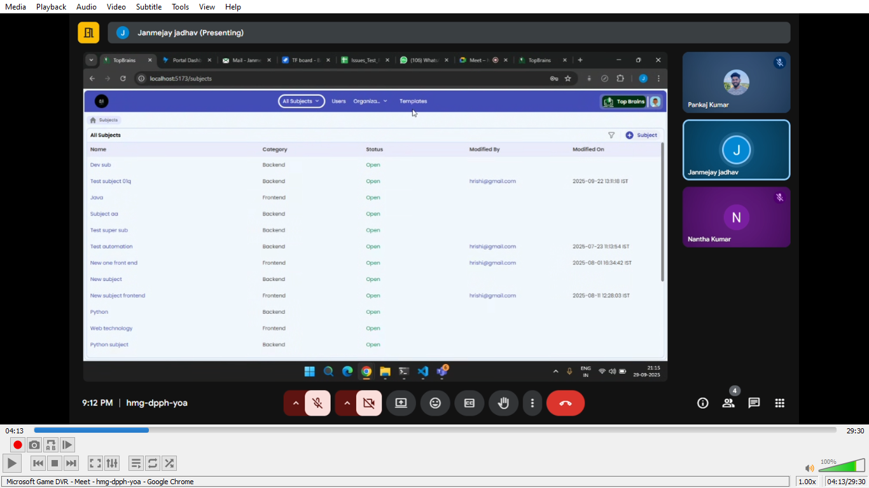

Here the Navbar contains (that the superadmin can create)
- All subjects
- Users
- Organization
- Templates

All subjects
- Can create subjects like
Frontend- eg; html, css an js
Backend-eg; java,
In right corner we can see two icon
1.for creating subject
2. for filter

1)if we click on create subject

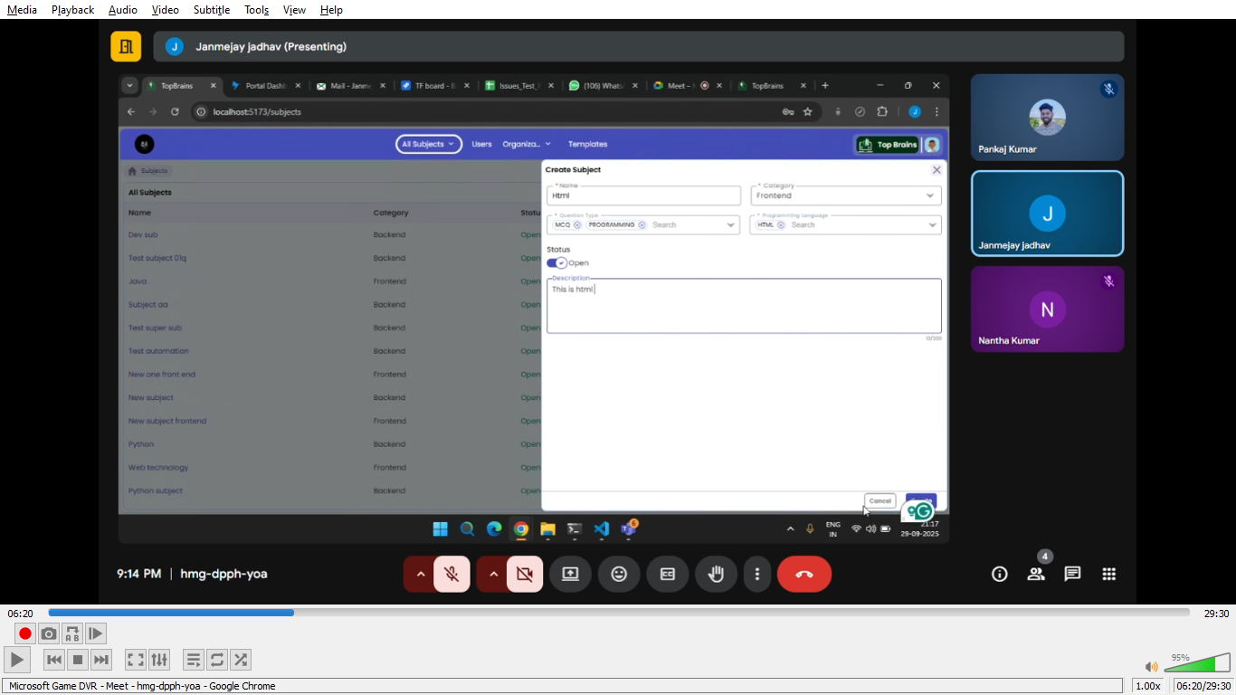
After create
It will added in the list->we can modify or delete

If user click on the subject-> superadmin will get the data in tree like structure

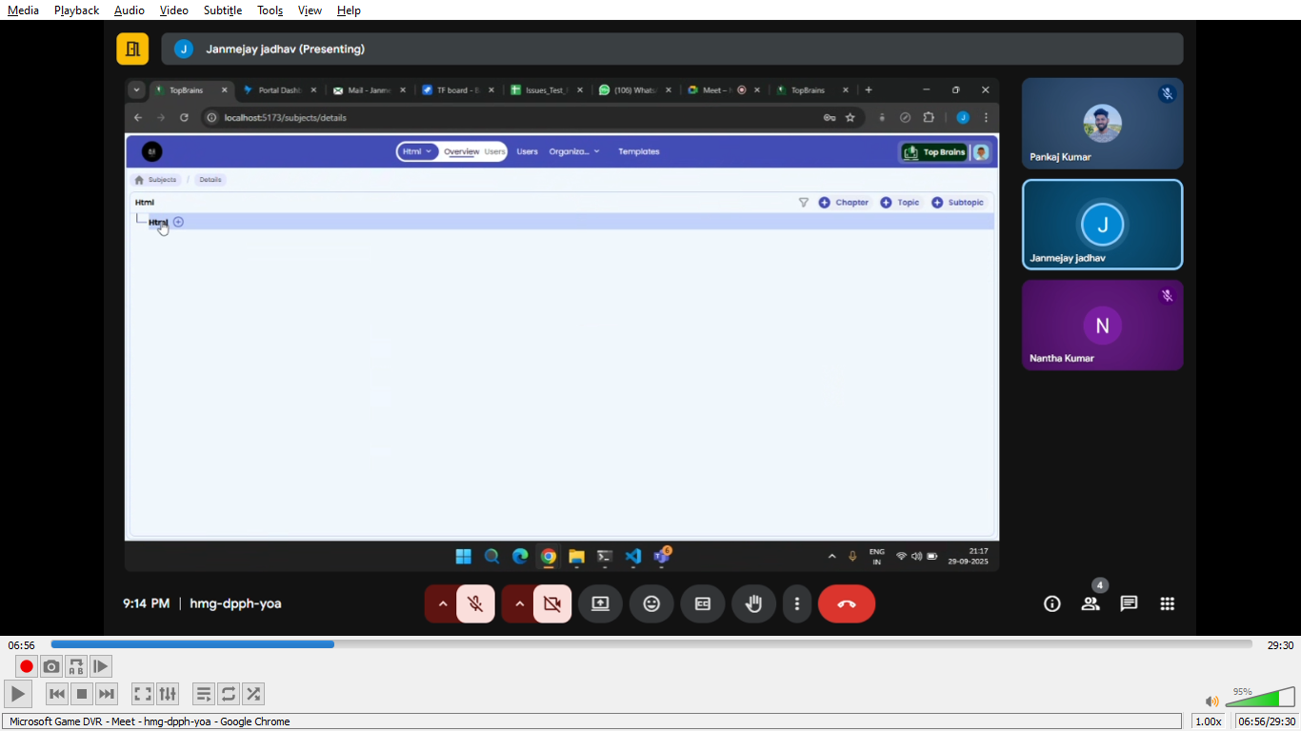

In subject we have
- Chapter
- Topic
- SubTopic
To create , also superadmin can see icon on top right corner to create also to filter

Creating chapter chapter is created
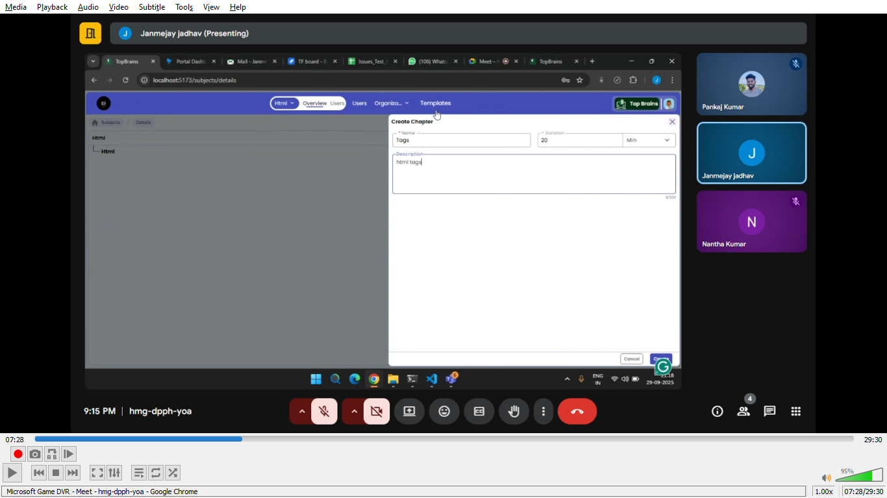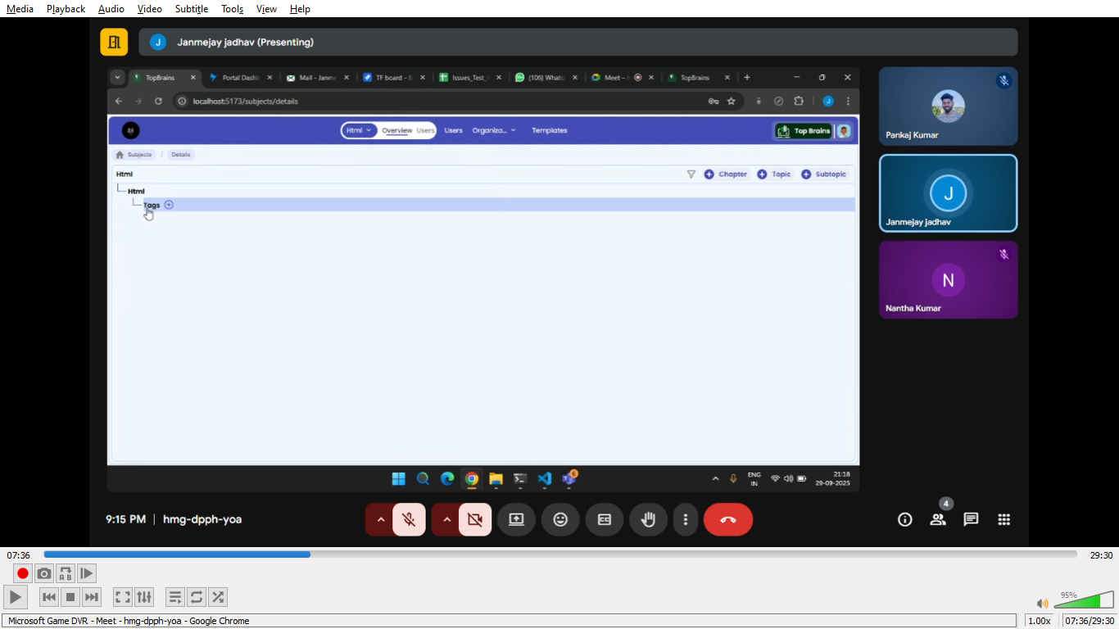
Same way for topics and subtopics
Only superadmin have the access to create subject
For this respective subject superadmin can add the user ->by clicking on navbar user
(there are two user option one for respective subject one is for only users)

User

Under user ->superadmin will get the option on top righ corner to create user
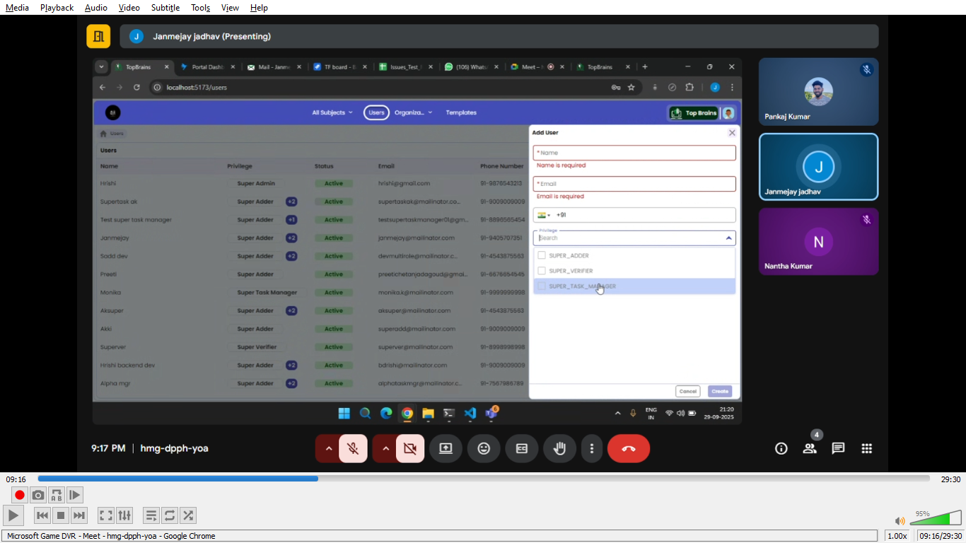
One verification mail will be sent to user->for confirmation

One user can have multiple roles

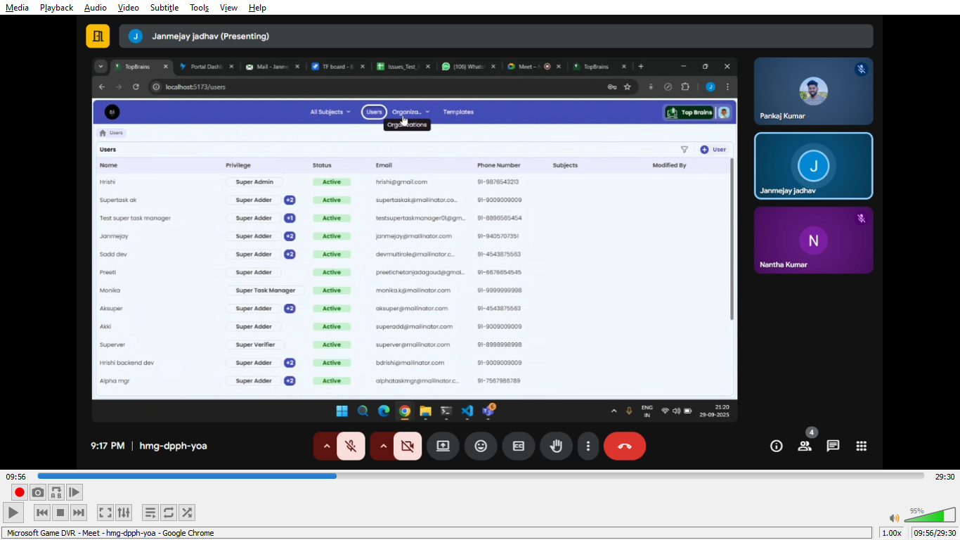

Organization
If we are developing application for test yantra->all super roles are associated with test yantra
Under that we have other organization like qspider or jspider, or any college or company

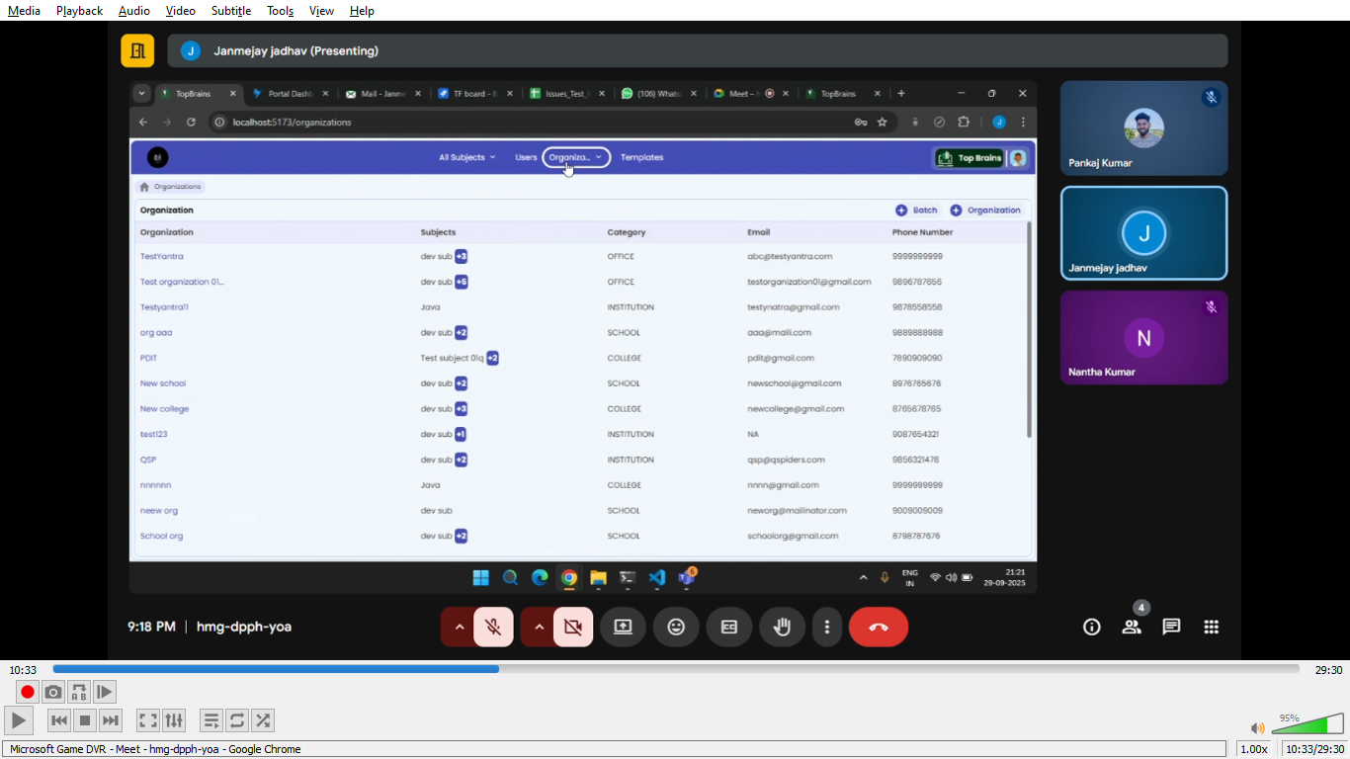

Creating organization
On right corner super admin can find the icon, also with add batch

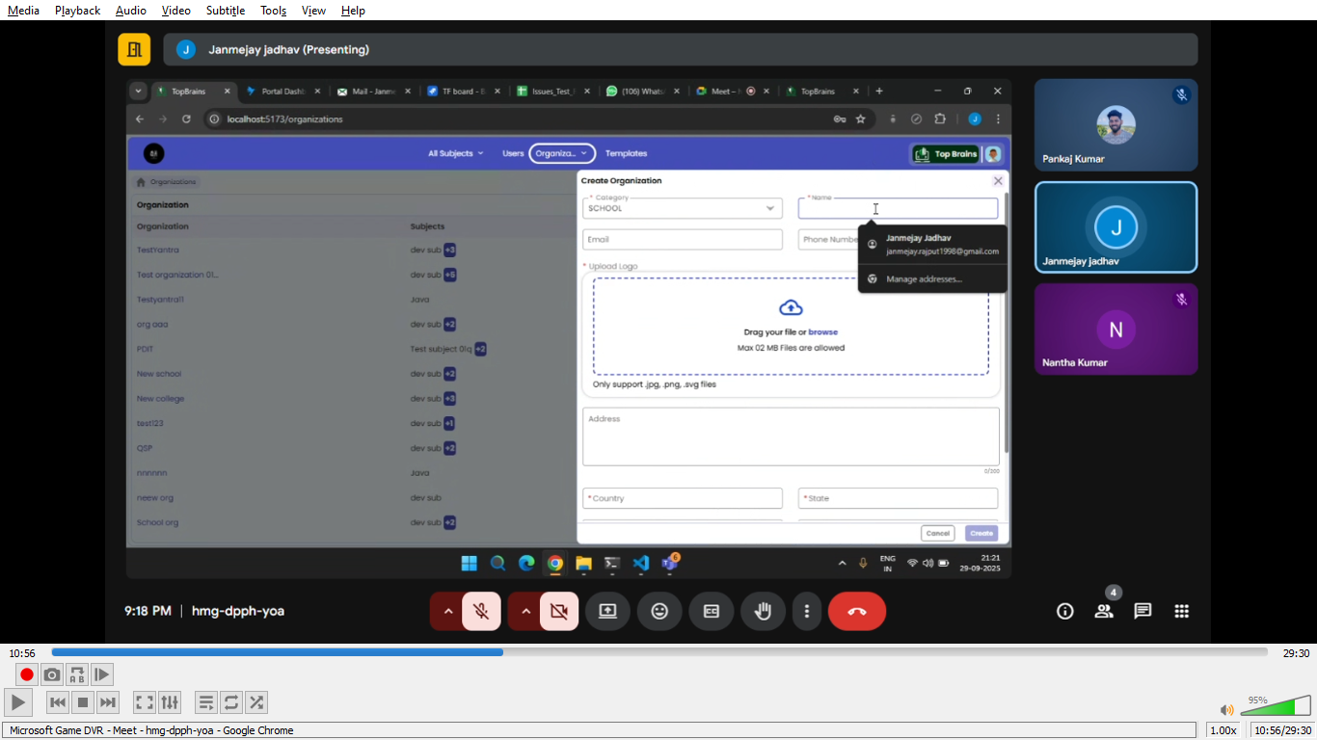
On scroll down

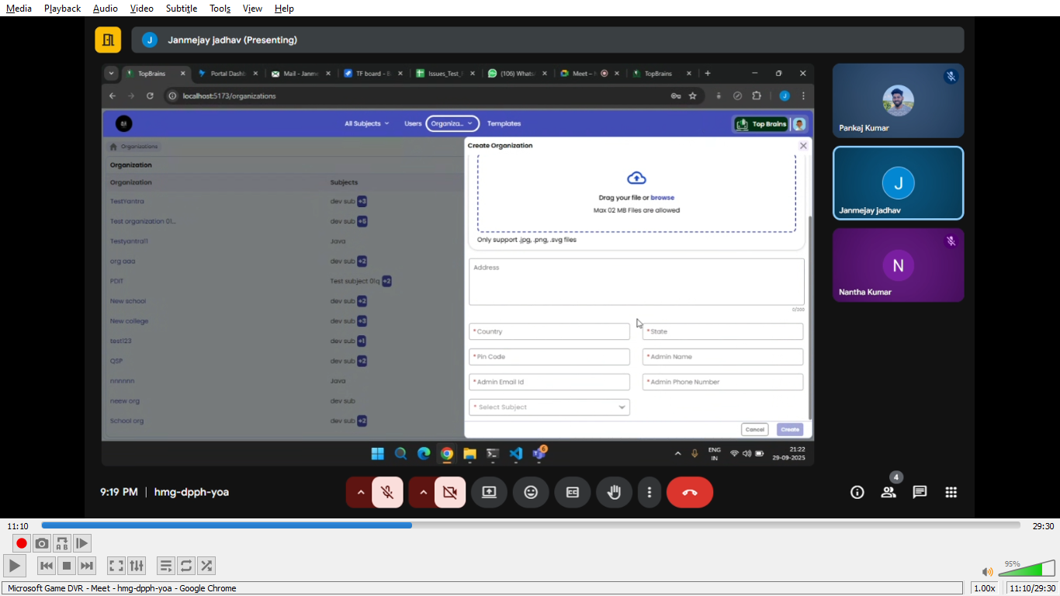
superadmin have to add admin here for that respective organization

Template

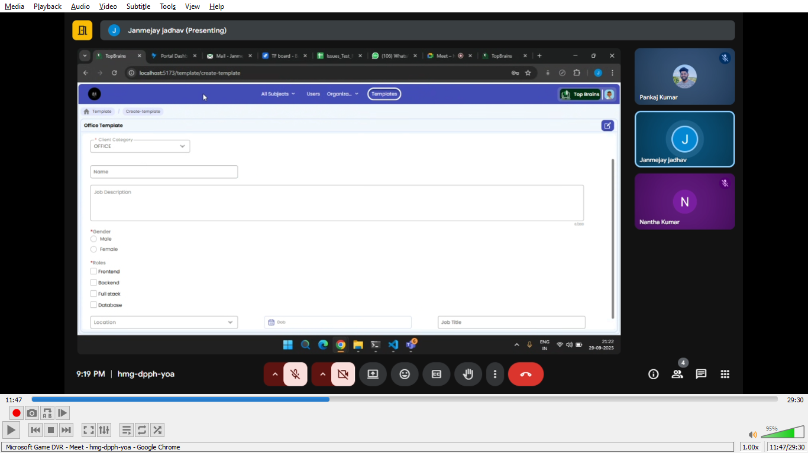

If we have created test yantra ->some students need to onboarding
So onboard to that student -> what details needed from candinate for onboarding
We will get the dynamic form

